Code Operation Guide
- Running environment
In the root of the code, running “pip install -r requirements.txt” will install the environment. Python version is 3.7.
Code directory of reading data sets
- Overall
Checkpoint of training
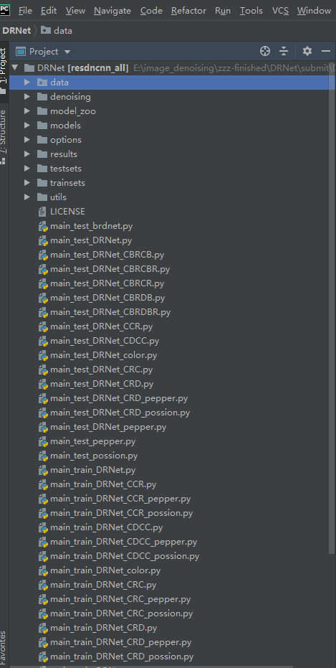
Train and test files
Tool files
Datasets
The results of the tests
Configuration files
Model file based on pytorch
Pre-trained model
- Training
We use DRNet as an example of training and testing, and others are similar.
The configuration file is in the “options” directory
3.1 Gaussian noise
The dateset can be obtained by referring to the the paper or “Readme.md” file.
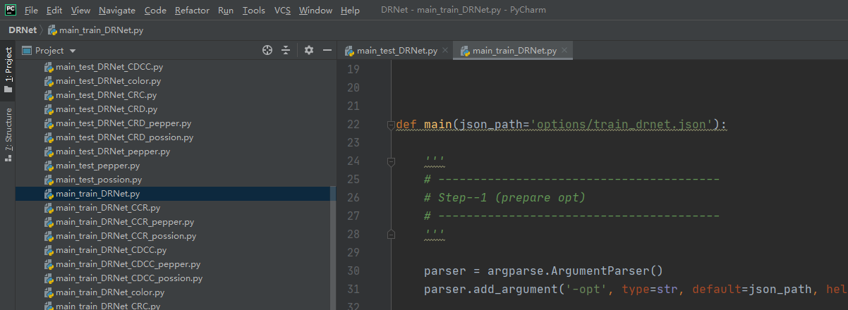
For color images
For gray images
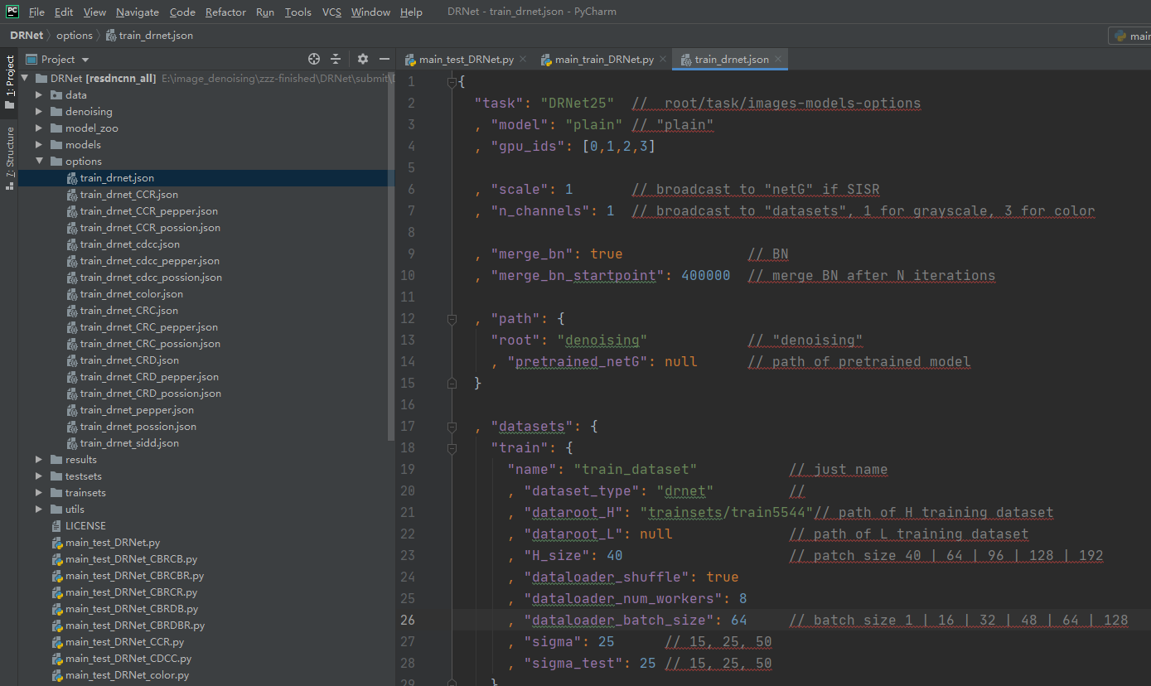
The parameters are accompanied by notes
Running :
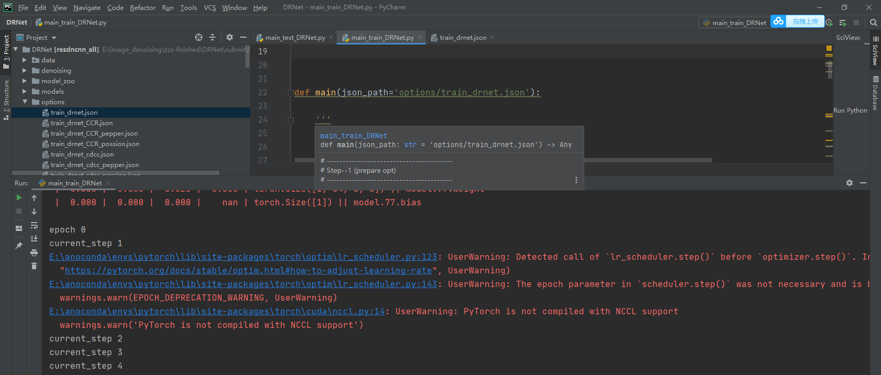
3.2 Possion noise and salt & pepper noise
It needs to be clarified that in this paper we do Poisson and salt and pepper noise tests on four better resblocks. So these noises are not tested on DRNet_CBRCB, etc.
3.3 Real noise
For real noise dataset, we use sRGB images from SIDD(http://130.63.97.225/sidd/dataset.php). Please download the dataset and put the “Data” directory in “trainsets”. Besides, the validation data should be put in testsets
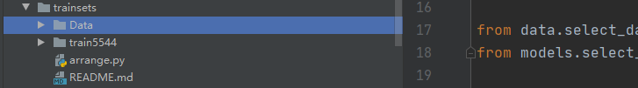
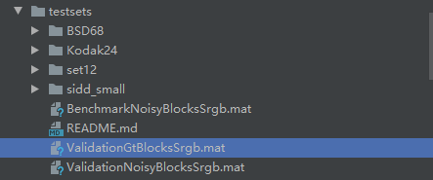
Running:
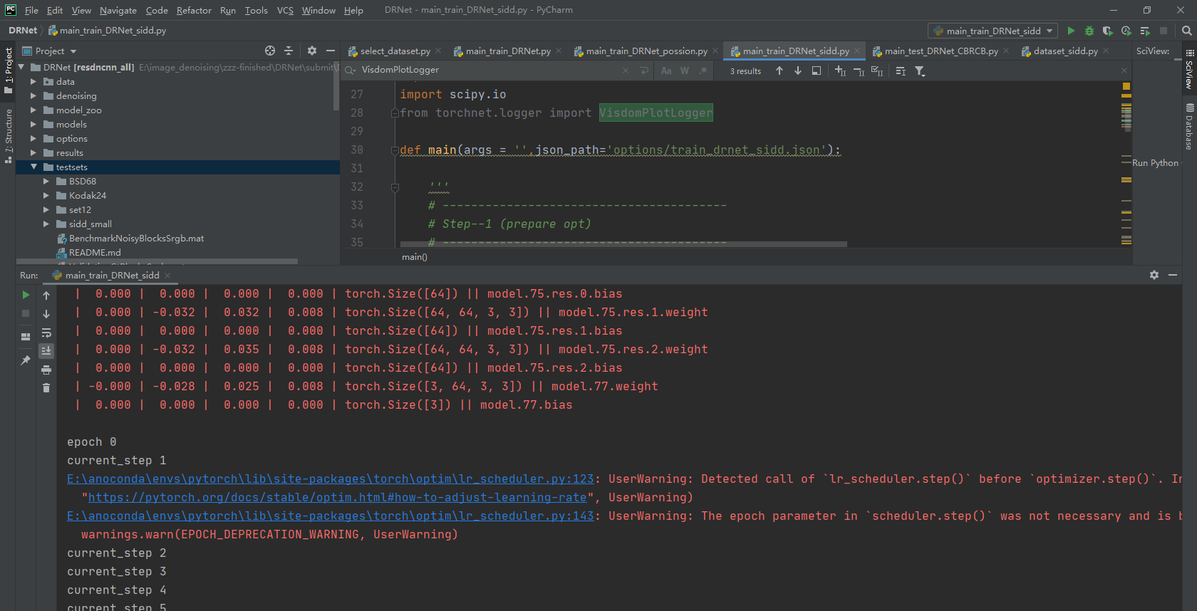
- Test
We provide test code and pre-trained model in the code.
Change the noise level here, 15, 25, 50
4.1 Gaussian noise
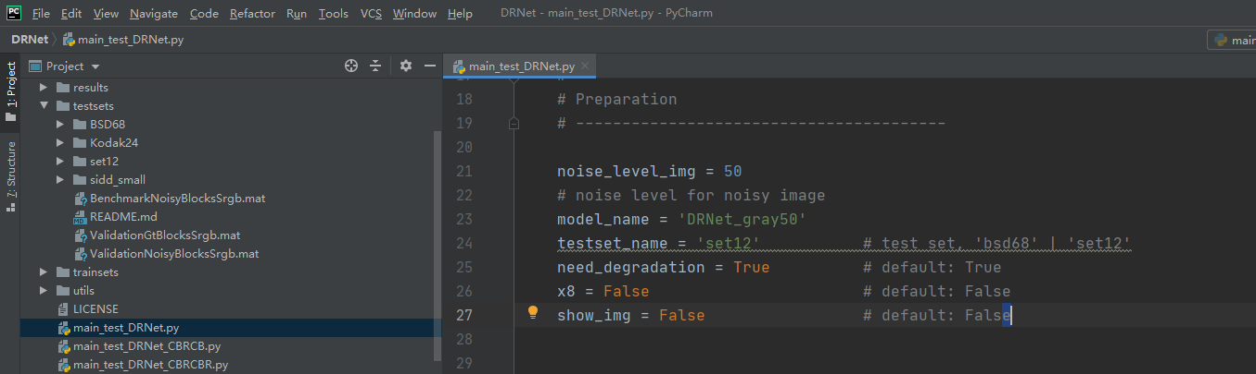
Testset
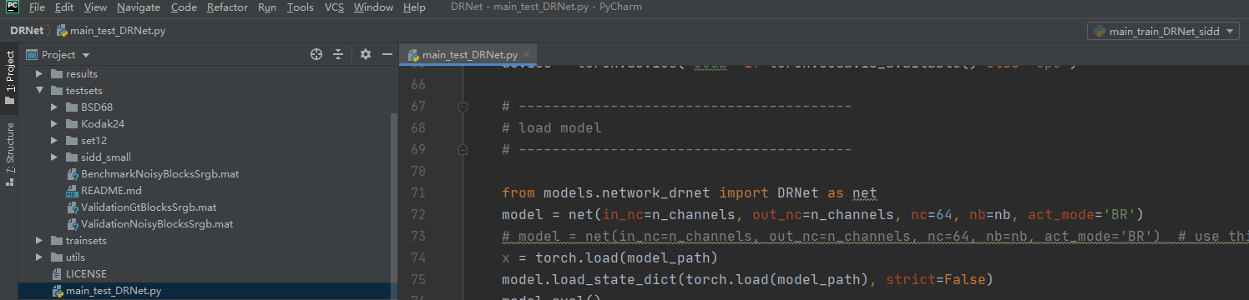
Changing the test model or you can run the corresponding test file directly
Running:
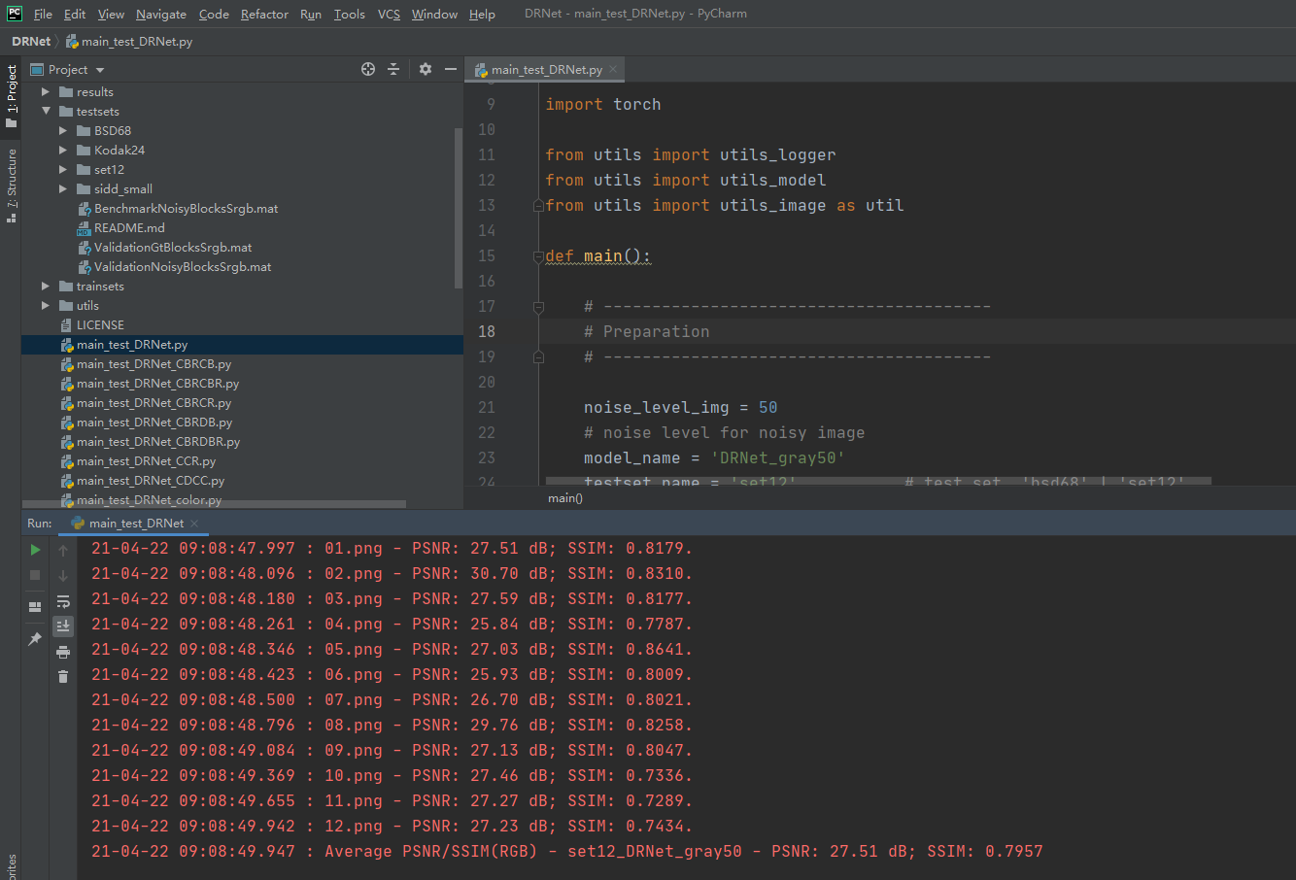
The output images:
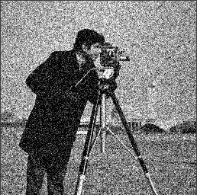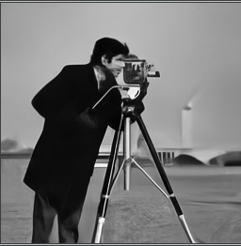
4.2 Possion noise and salt & pepper noise
The experiments of possion noise and salt & pepper noise are used as a contrast in ablation experiments. So we didn't compare DRNet with other networks dealing with this kind of noise specially.
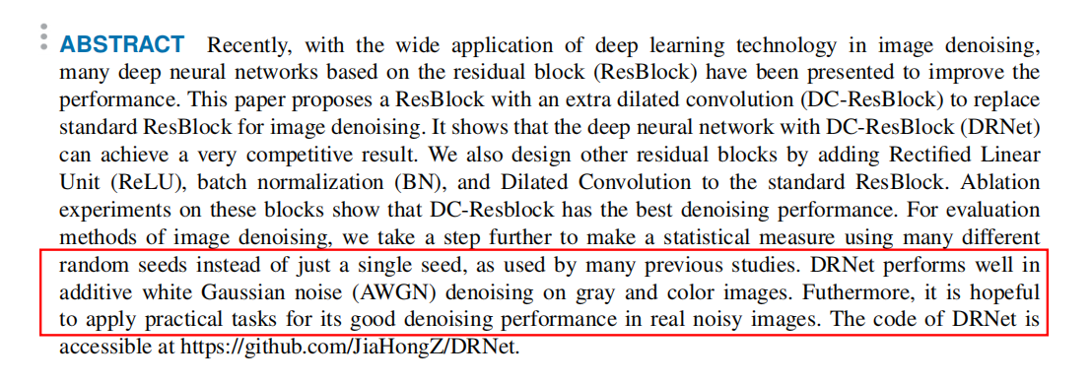
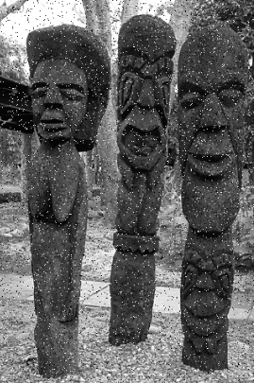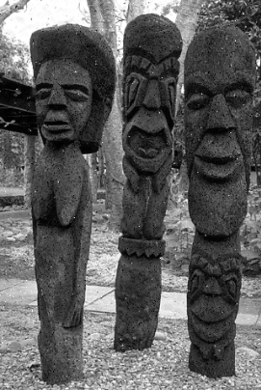
4.3 Real noise
We use the official test method provided by SIDD data set for real noise testing. Run the “Submit.py” to generate a file named “SubmitSrgb.mat”, then submit it to http://130.63.97.225/sidd/benchmark_submit.php
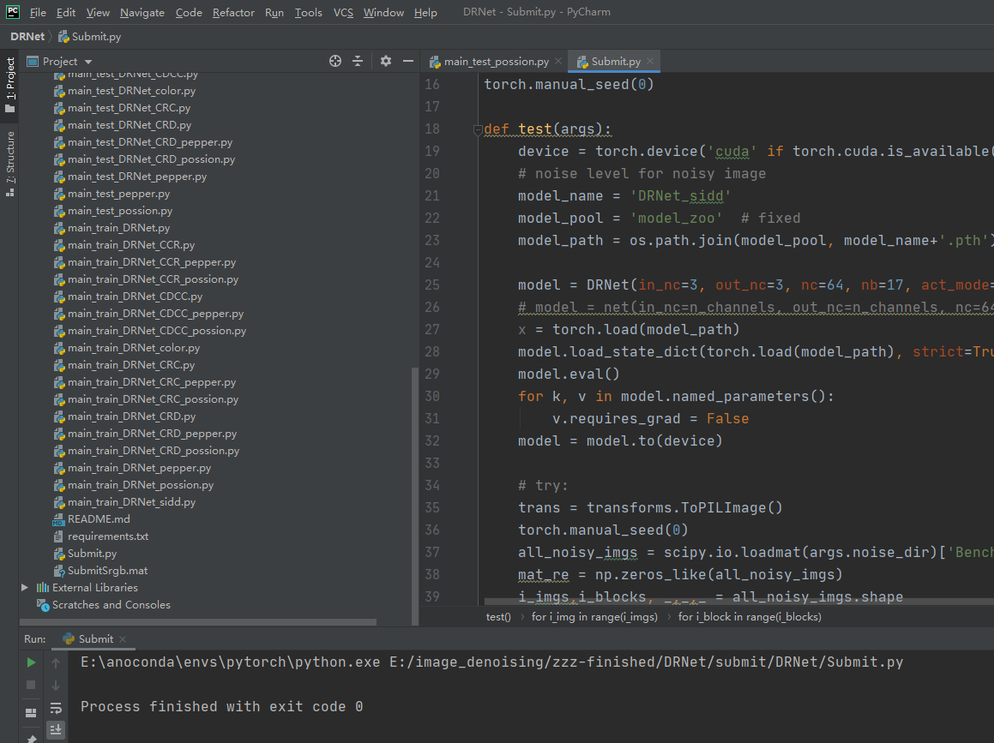
The results obtained by the mailbox are as follows:
PSNR_Srgb,SSIM_Srgb,TimeSrgb(s)
36.33,0.931,-1
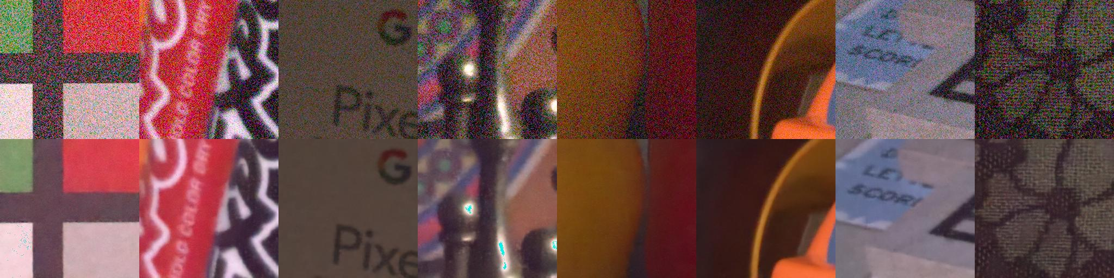
If you want to test other real noise images, you can modify the main_test_DRNet.py.

